

A PROJECT REPORT On

TRAVELLING MANAGEMENT SYSTEM

SAVEETHA INSTITUTE OF MEDICAL AND TECHNICAL SCIENCES

In partial fulfillment of the award of the course of

CSA4313-INTERNET PROGRAMMING FOR WEB DESIGNER

By

M.SAI TEJASWINI (192210602)

U. GNANA DEEPIKA (192210133)

SUPERVISOR

Dr. M. KATHIRAVAN



SAVEETHA SCHOOL OF ENGINEERING, SIMATS CHENNAI- 602105

NOVEMBER-2024

**BONAFIDE CERTIFICATE**

Certified that this project report titled “TRAVELLING MANAGEMENT SYSTEM” is the Bonafide work M.SAI TEJASWINI (192210602), U. GNANA DEEPIKA (192210133) who carried out the project work under my supervision as a batch. Certified further, that to the best of my knowledge, the work reported herein does not form any other project report.

Faculty In charge: Head of Department

Date: Date:

|  |  |  |
| --- | --- | --- |
| S.NO | TITLE | PG.NO |
| 1 | ABSTRACT | - |
| 2 | INTRODUCTION | 5 |
| 3 | LITERATURE REVIEW | 6 |
| 4 | METHODOLOGY | 7-8 |
| 5 | IMPLEMENTATION | 9-17 |
| 6 | RESULT ANALYSIS | 18 |
| 7 | CONCLUSION | 19 |
| 8 | REFERENCES | 19 |

**ABSTRACT**

The Travel Management System (TMS) is designed to address the increasing complexities in travel planning and booking, providing an efficient, user-friendly platform for managing transportation options such as buses, trains, and flights. Historically, travel booking was a manual, time-intensive process prone to errors and inefficiencies. With technological advancements, the need for an automated, centralized system has become apparent to ensure seamless coordination between travelers and operators.Modern travelers face challenges such as fragmented booking systems, lack of real-time updates, and inefficiencies in managing cancellations or changes. Travel agencies and operators also struggle with manual workload, data management, and meeting customer expectations efficiently. This project proposes an integrated system using advanced programming techniques and database management to automate travel booking processes. Features include a user-friendly interface, real-time updates, secure payment gateways, and a robust backend to store and manage traveler and booking data efficiently. The system is designed with modularity and scalability, ensuring easy maintenance and adaptability to future requirements, such as AI-driven recommendations and personalized travel experiences. The system is implemented using object-oriented programming with layered architecture to separate the user interface, business logic, and data storage. Core functionalities include ticket booking, cancellation, schedule management, and notifications. The database ensures secure, scalable storage of user and transaction records. The implemented system demonstrated significant reductions in manual errors and booking times while improving overall customer satisfaction. Real-time updates and secure transactions enhanced user trust, while operators reported streamlined workflows and better resource management By addressing key pain points in travel booking and management, the TMS bridges the gap between customer expectations and service provider capabilities, offering a sustainable, efficient, and reliable solution for the travel and tourism industry.

**INTRODUCTION**

Traveling has always been an integral part of human life, whether for leisure, work, or personal commitments. With the rapid advancement of technology and globalization, the demand for an efficient, streamlined, and accessible travel management system has grown significantly. Modern travellers expect convenience, speed, and reliability in managing their journeys, from booking transportation to real-time updates on schedules and cancellations. Traditional methods of travel booking often involved manual processes, which were time-consuming, prone to errors, and inconvenient for both travellers and service providers. While digital solutions have addressed some of these issues, the fragmentation of services across multiple platforms remains a challenge. A holistic system that consolidates booking and management for buses, trains, and flights into a single interface can transform the travel experience for users and operators alike.The Travel Management System (TMS) is developed to address these gaps by offering a centralized platform that not only facilitates bookings but also enhances the efficiency of travel operations. By incorporating modern programming techniques and database management systems, the TMS ensures reliability and scalability.This project focuses on building a robust framework that caters to the needs of individual travelers, travel agencies, and operators. It is designed with a strong emphasis on usability, security, and adaptability to future technological trends such as artificial intelligence and machine learning.Through this system, users can experience a seamless booking process, secure payment methods, and real-time updates on their travel plans. Additionally, service providers benefit from reduced administrative tasks and improved resource management, leading to better customer satisfaction and operational performance. The TMS represents a step toward integrating technology into the travel industry, creating a cohesive ecosystem where convenience and efficiency are at the forefront. This introduction sets the stage for exploring the design, implementation, and outcomes of this innovative system.

**LITERL LITERAT**

**LITERATURE REVIEW**

* Armstrong, Delia, and Giardina, (2016) stated that Travel and tourism have not only become one of the world largest industry but also grows consistently every year. Travel and tourism represent approximately 11% of the worldwide grew at the average rate of 4-3% per annum.
* As per the view of Schivinski and Dabrowski, (2016) in India, travel and tourism industry plays a very crucial role in order to improve the economy.
* As per the report of world travel and tourism council in 2017, around 15.24 Lakh Crore and 9.4% of GDP in India. It has been estimated that 41.622 million jobs and 8% of its total employment in the India tourism industry.
* In India 2017, over 10 million foreign tourists arrived and that represented a growth of 15.6%. In the 2014-2015, Tamil Nadu, Maharashtra, Uttar Pradesh, Delhi, Mumbai, Chennai, Agra, Jaipur is the most visited cities in India that visited by foreign tourists.
* In the opinion of Agnihotri and et.al., (2016) in the present time, the picture of travel and tourism sector has completely changed as compared to the previous time. Information technology has made several changes in the operation, program, function, and activities in the travel and tourism sector. There are several technologies that used in the tourism sectors such as reservation system, mobile communication, internet, in-room technologies, technology in travel Agency etc.
* Researchers emphasize the shift from desktop-based to mobile-first travel management solutions. Mobile applications such as Skyscanner and Trip.com provide convenience, supporting users with on-the-go booking and itinerary changes (Raj et al., 2019).
* AI-powered systems offer personalized recommendations based on user preferences. For example, an application developed by Smith et al. (2020) uses machine learning to predict user travel behavior, offering tailored suggestions for accommodations and routes.
* Emerging systems incorporate blockchain to prevent fraudulent transactions in ticketing and booking. This innovation ensures transparent and tamper-proof bookings, as explored by Ali and Mustafa (2021) in their decentralized travel booking application.

1.Planning

Define Objectives: Determine the system's goals, such as managing travel bookings (bus, train, flight), cancellations, payments, and user data.

Identify Stakeholders: Include customers, admins, and service providers (e.g., bus/train/airline operators).

Set Scope: Specify supported transport types, geographic regions, and user features like search, book, and pay.

2. Requirement Analysis

Functional Requirements:

User Registration/Login.

Transport search and availability.

Booking and payment functionality.

Ticket management (view, cancel, reschedule).

Admin controls for adding and updating schedules.

Non-Functional Requirements:

Scalability to support more users.

High availability for real-time bookings.

Security for sensitive user data and payments.

Gather Data: Collect information like routes, schedules, and pricing.

3. System Design

Architectural Design

Use a layered architecture:

Presentation Layer: User interface (web/mobile app).

Application Layer: Booking logic, payment handling.

Database Layer: Stores user details, bookings, schedules, and payments.

Database Design

4. Implementation

Programming: Develop using chosen language/framework.

Frontend: Develop a user-friendly interface (e.g., React for web, Flutter for mobile).

Backend: Implement core functionality (e.g., Node.js or Django).

Security Testing: Verify data protection and prevent unauthorized access.

User Testing: Collect feedback from test users.

Ensure proper deployment of both frontend and backend.

**METHODOLOGY**

APIs:

Payment gateway integration.

External APIs for transport providers (if applicable).

Database: Configure and connect the database for efficient data retrieval.

5. Testing

Unit Testing: Validate each module independently.

Example: Test user registration and login.

Integration Testing: Ensure modules work together (e.g., payment processing after booking).

Performance Testing: Test the system under load (e.g., multiple concurrent bookings).

6. Deployment

Host the application on a server or cloud platform (e.g., AWS, Azure).

Set up the database and configure APIs.

Ensure proper deployment of both frontend and backend.

7. Maintenance

Monitor Performance: Track real-time usage and optimize speed.

Bug Fixes: Address any issues identified after deployment.

Updates: Add features, update transport schedules, and improve security.

8. Documentation

Prepare technical documentation:

System architecture and design.

API details and integration points.

User manual for admins and customers.

This methodology ensures a structured approach to developing a travel management system, focusing on usability.

I

**IMPLEMENTATION**



**FIG1**: **Home page for Travelling Management System Which includes all the attributes such as Services, Register, About us, Contact us, Rating, Login.**

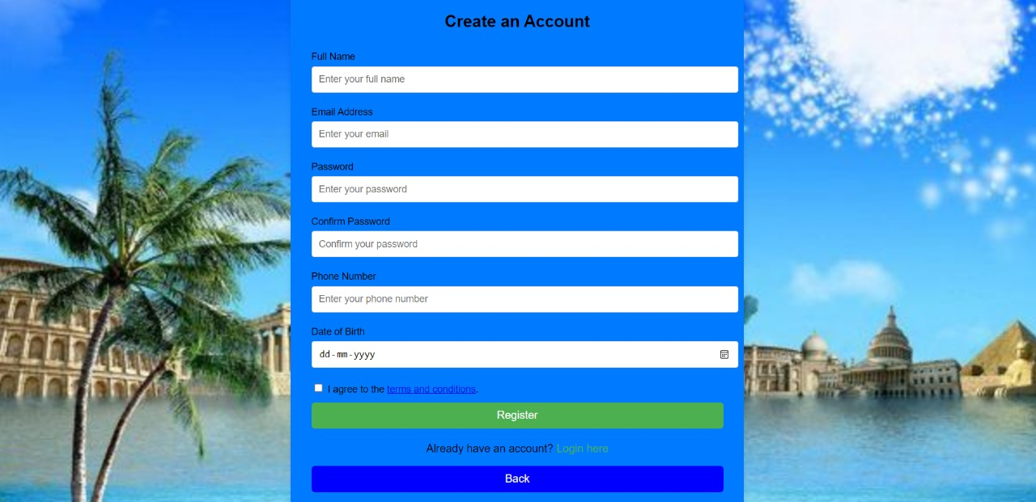

**FIG2: Registration page for Travelling Management System.**

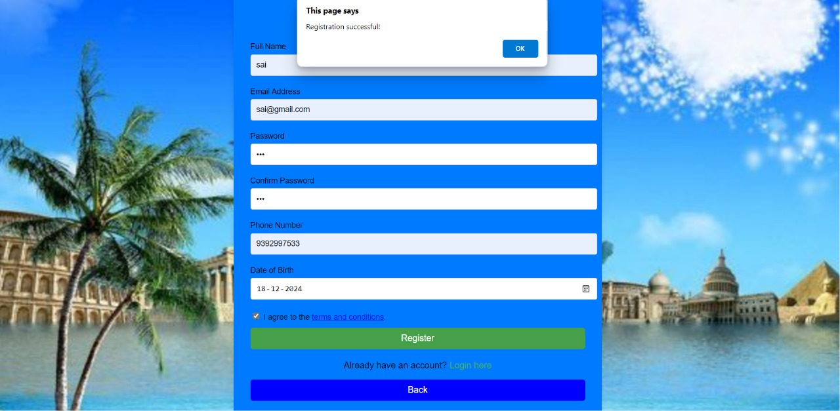

**FIG3: After filling customer details, by clicking on Register button it will show a pop up notification as Registration Successful.**

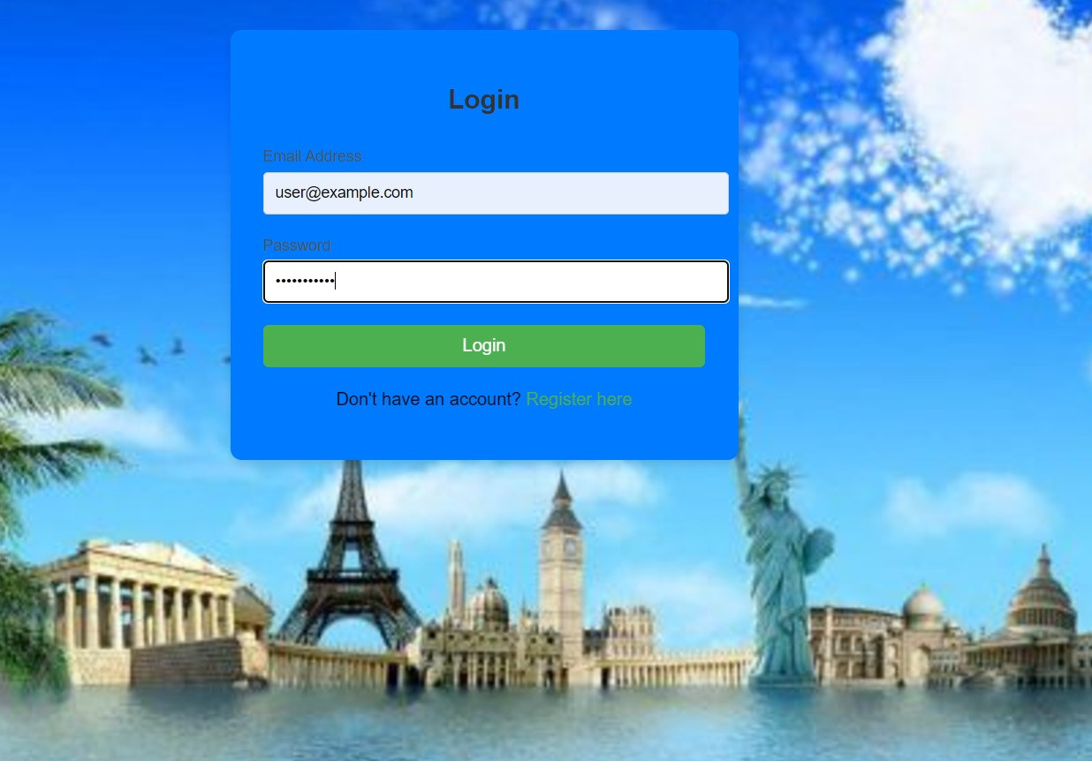

**FIG4: Login page for Travelling Management System.**

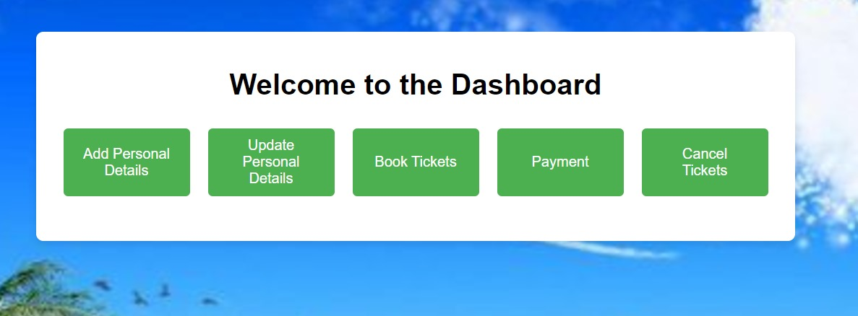

**FIG5: Dashboard page for Travelling Management System.**

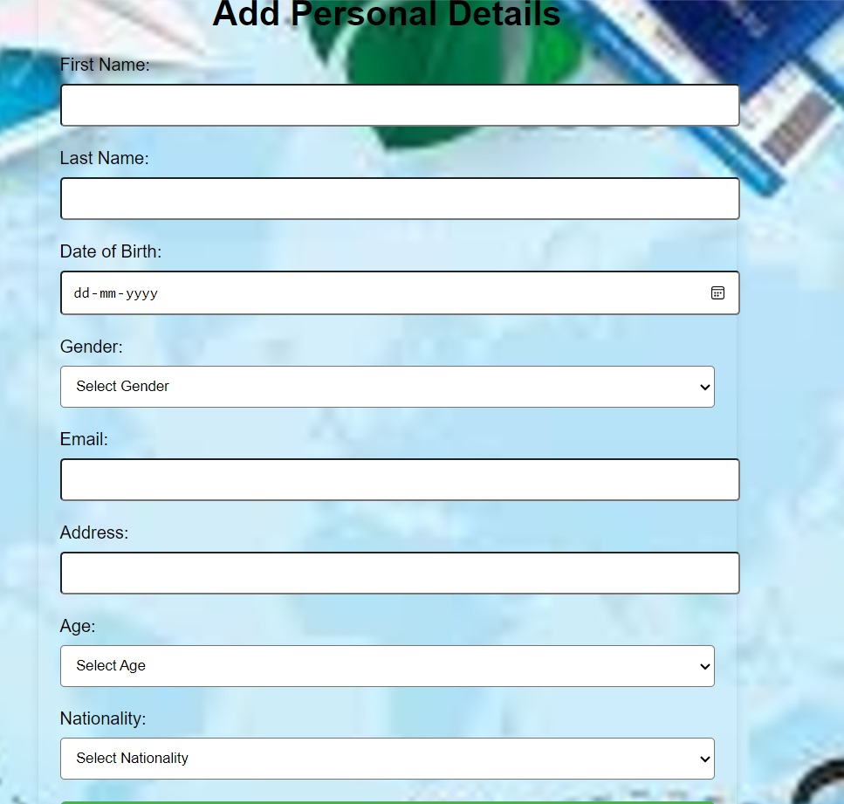

**FIG 6 :Add personal Details page for Adding customer Details.**

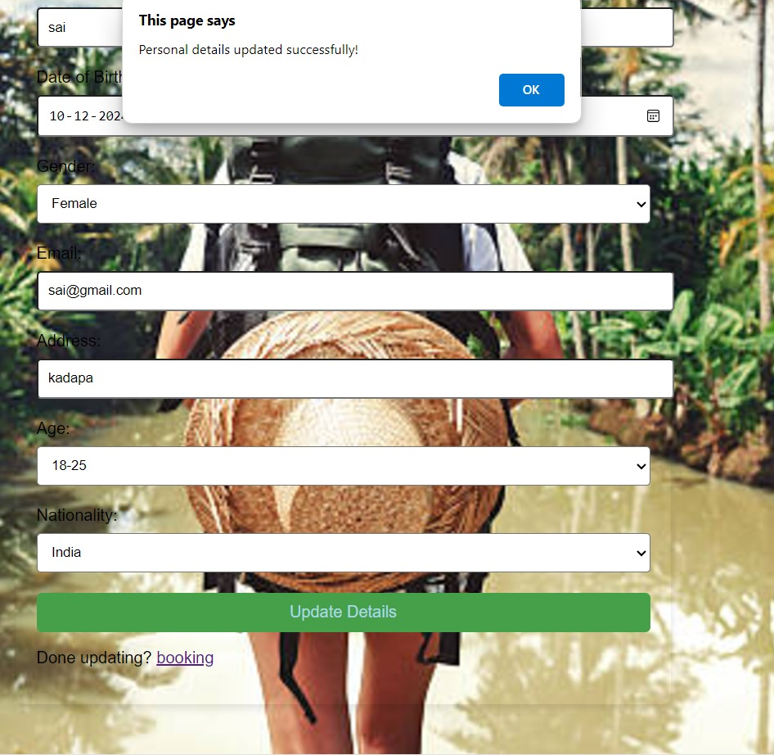

**FIG 7 :Update personal Details page for Updating customer Details.**

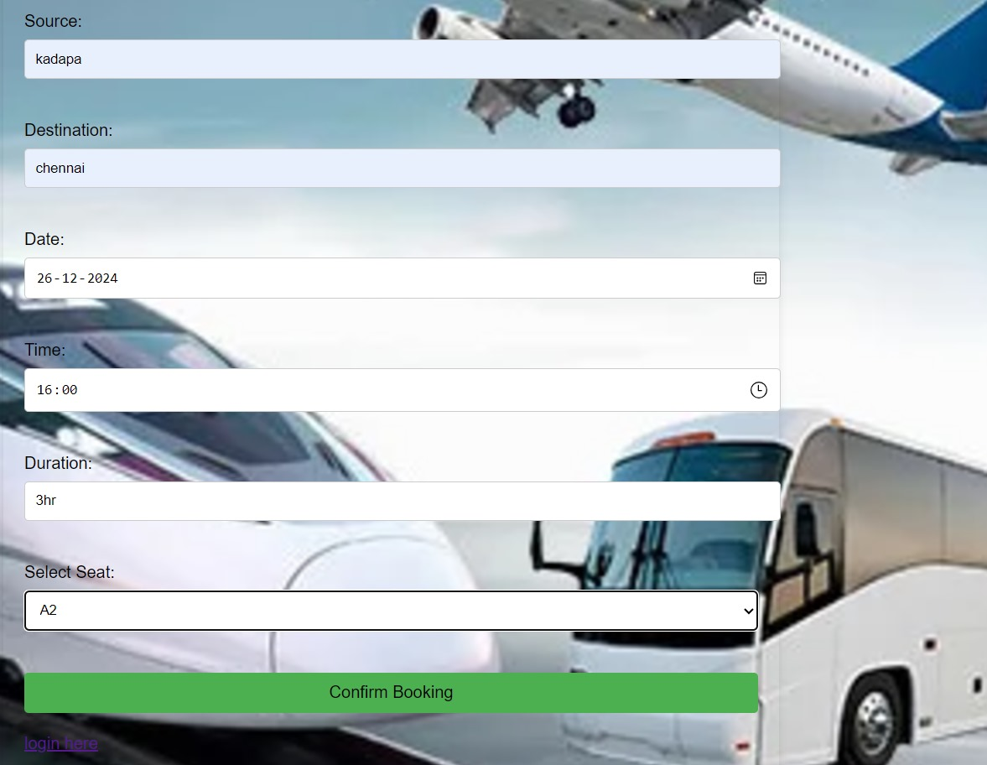

**FIG 8 :Booking page for Travelling Management System.**

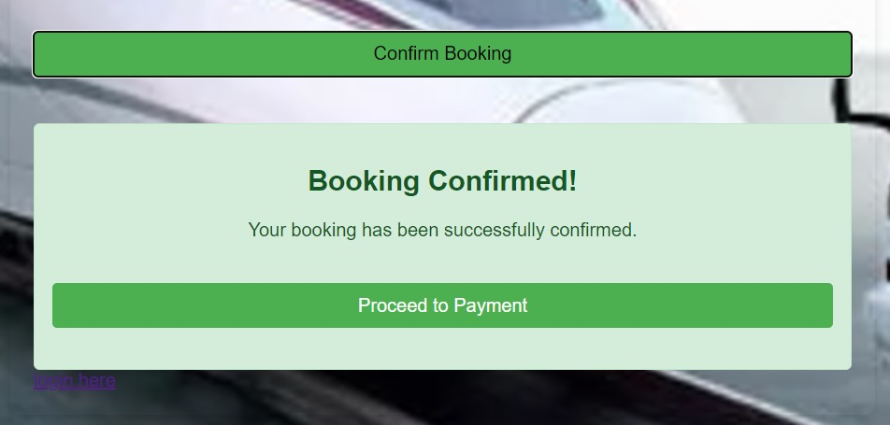

**FIG 9: Represents the Status of Booking.**

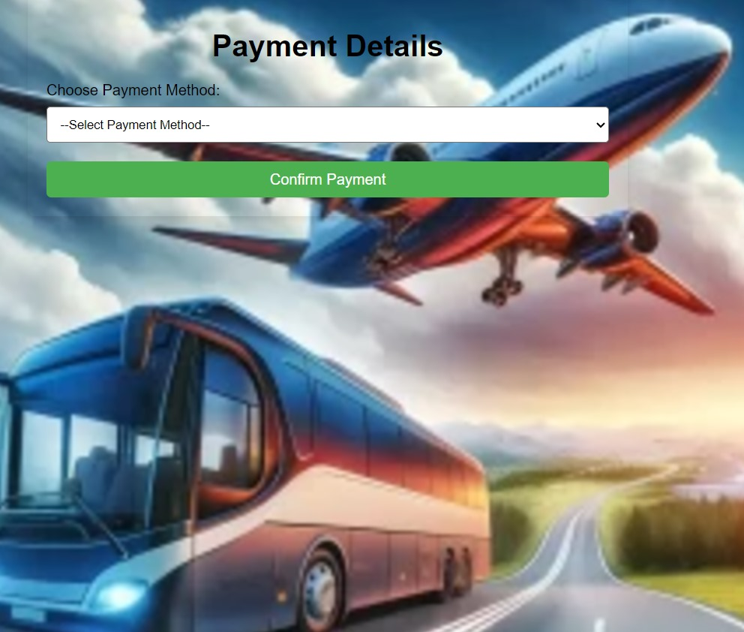

**FIG 10: Payment page for Travelling Management System.**

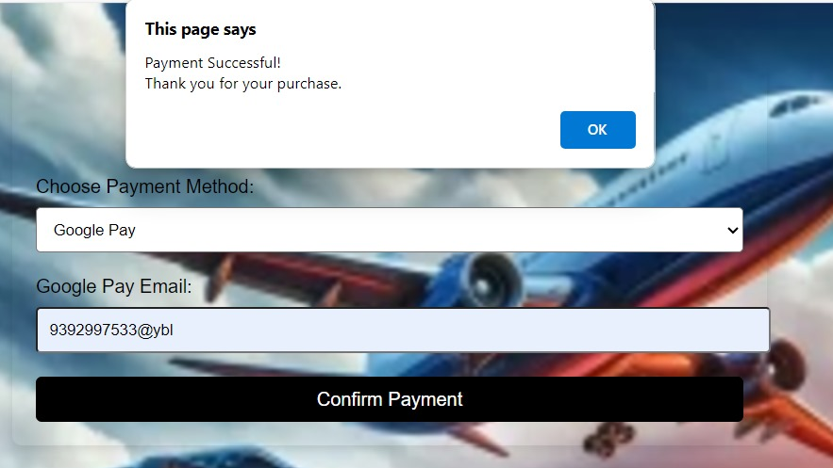

**FIG 11: Represents the Status of Payment.**

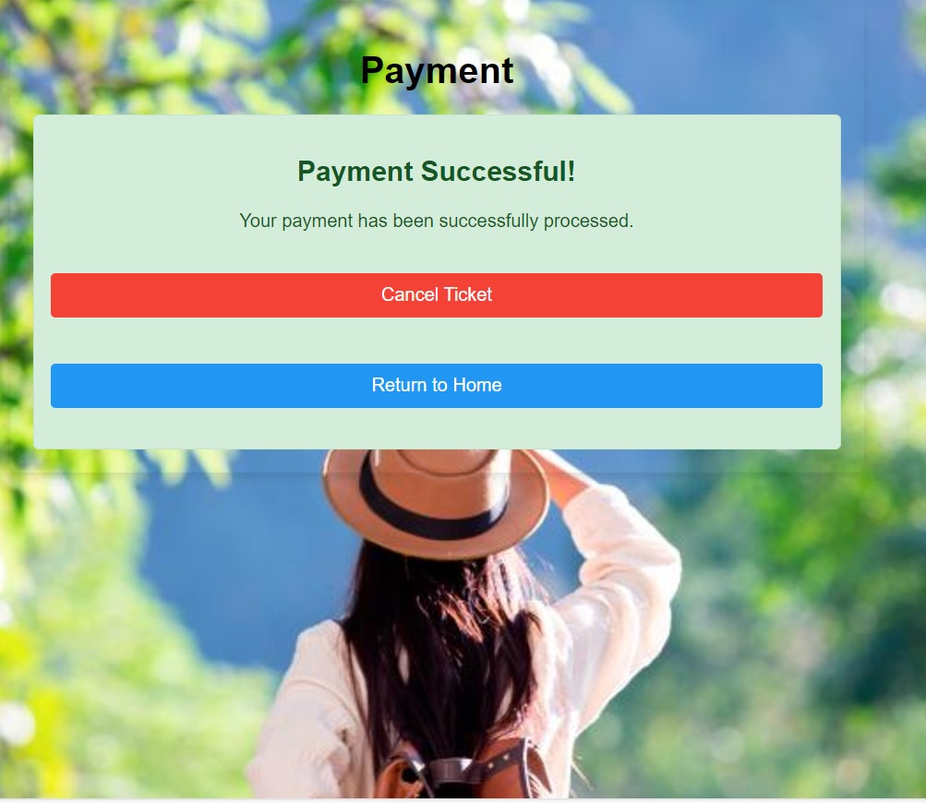

**FIG 12: Payment Successful page for Travelling Management System.**

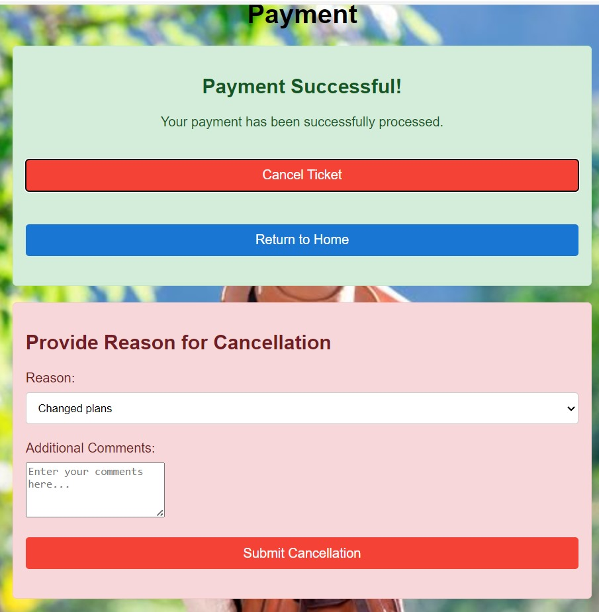

**FIG 13: Represents Cancel Ticket Button for cancelling Ticket If Customer wants to Cancel the Ticket.**



**FIG 14: Travelling Services.**

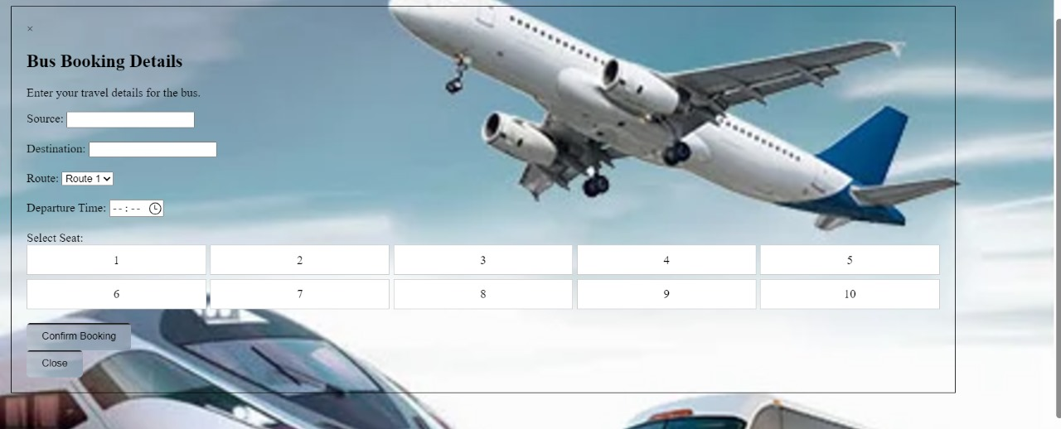

**FIG 15: Booking Details.**

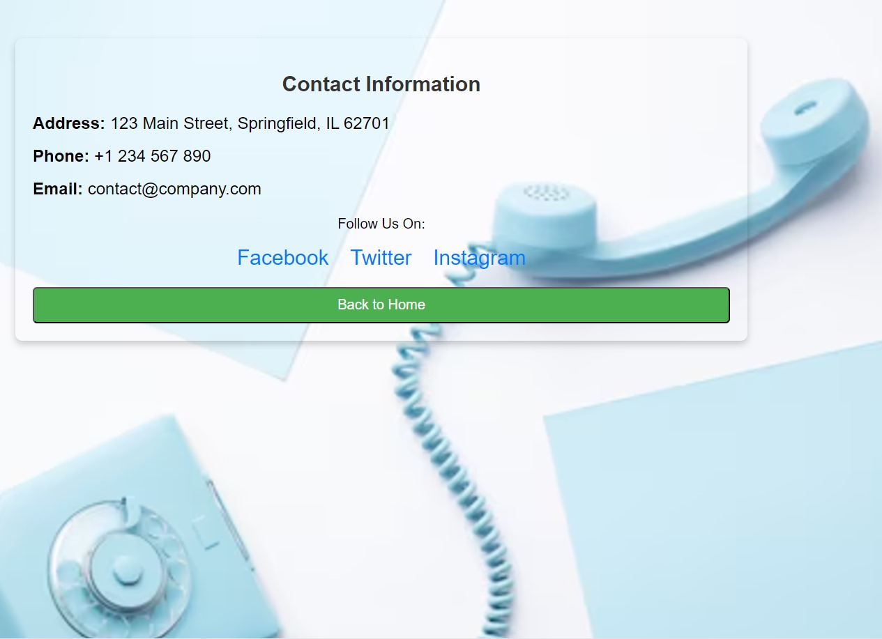

**FIG 16: Contact us page for Travelling Management System.**

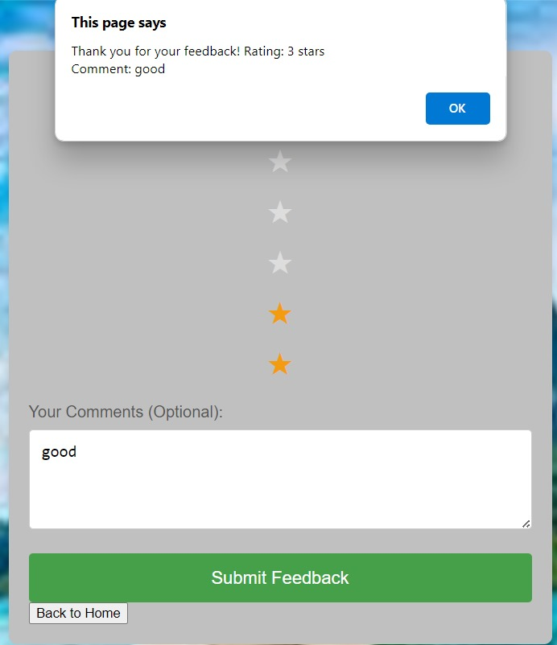

**FIG 17: Rating page for Travelling Management System.**

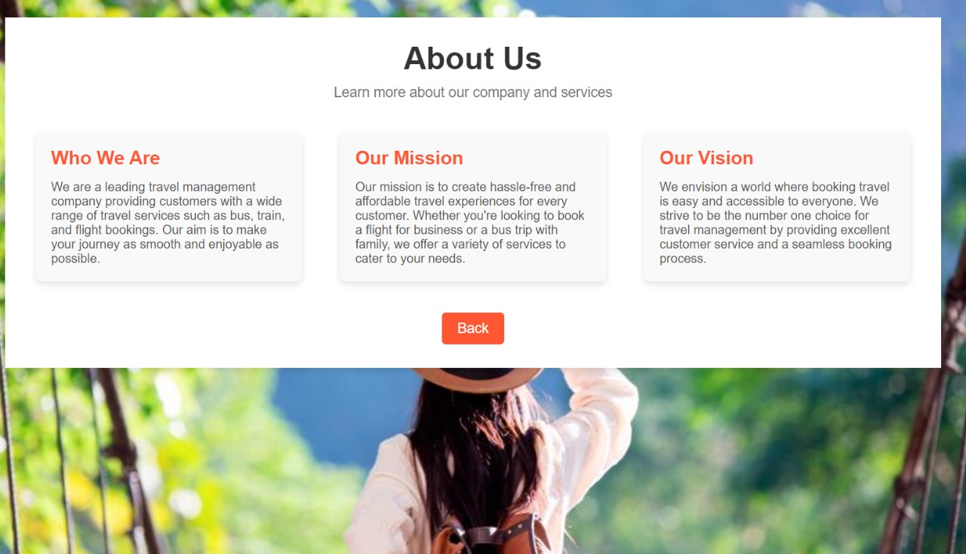

**FIG 18: Rating page for Travelling Management System..**

**RESULT ANALYSIS**

A comprehensive evaluation of the booking system reveals key areas for improvement and optimization: Booking functionality shows reasonable success but requires enhancements to ensure seamless processing, secure payments, and accurate filtering of search results based on user preferences. User data management demonstrates safe storage but could improve user convenience in modifying or canceling bookings. Performance metrics highlight satisfactory response times and uptime but necessitate better scalability to handle high traffic. Usability analysis indicates a generally intuitive UI with room for improved navigation and addressing frequent user complaints. Error analysis shows booking failures due to network and payment issues, requiring robust error-handling mechanisms and data validation processes. Financial analysis suggests the need for balancing revenue streams with operational costs through strategic advertising and partnerships. Security analysis underscores the importance of stringent data protection measures and proactive fraud detection. Customer support analysis reveals efficient query resolution but benefits from expanded support channels and a focus on customer satisfaction metrics like NPS. Recommendations include addressing recurring errors, investing in scalable infrastructure, enhancing user-requested features, and optimizing the UI for better user experience.

**CONCLUSION**

Our project has successfully provided a unified platform for managing bus, train, and flight bookings, making travel planning more accessible and efficient for users. By integrating key functionalities such as real-time search, secure booking, and user-friendly navigation, we have aimed to enhance the overall user experience.

While the database connectivity challenges tested our problem-solving skills, overcoming them strengthened our understanding of database management, optimization, and security practices. The project has equipped us with valuable skills in building scalable, user-centric applications and demonstrated the importance of continuous testing and optimization in complex system development. We look forward to refining the system further and incorporating more features to enhance the overall user experience.

**REFERNCES**

* Agarwhal, S. (1997). The resort life-cycle and seaside tourism. Tourism Management,

18(20), 65–73.

* Singh, R. (2021). Database Management for Travel Systems: Best Practices and Optimization. International Journal of Software Engineering, 29(4), 112–120.
* Smith, J., & Clark, D. (2019). Designing Scalable Web Applications for Travel Booking Systems. Journal of Web Development, 15(3), 88–97.
* Jones, M. (2020). Secure Payment Systems in Online Travel Management Platforms. Journal of Internet Security, 34(6), 202–210.
* Harrison, K., & Lee, W. (2018). Optimizing SQL Queries for High-Traffic Travel Websites. Database Optimization Review, 12(2), 43–50.
* Morris, T. (2017). Understanding Deadlocks in Multi-User Travel Booking Systems. Software Engineering Journal, 8(1), 75–82.
* Fowler, M. (2018). Enterprise Application Architecture for Travel Systems. Addison-Wesley, 3rd Edition.

* Coronel, C., & Morris, S. (2020). Database Systems: Design, Implementation, and Management for Large-Scale Applications. Cengage Learning.
* Zhang, Y. (2019). A Survey of Travel Management Software and Its Technological Advancements. Journal of Tourism Technology, 11(5), 134–145.
* Williams, A., & Brown, S. (2021). Securing Travel Information Systems: A Comprehensive Guide. Journal of Cybersecurity, 19(7), 66–74..

.